IS312 Web Design and Programming: Introduction to HTML and CSS
HOS01B Experiencing HTML and CSS
9/18/2023 Reviewed by Ajay Naik
1/04/2024, Reviewed by Lakshmipathi Machineni
10/04/2024, Reviewed by Shahid Khan

School of Technology & Computing (STC) @ City University of Seattle (CityU)



Before You Start
- Version numbers may not match with the most current version at the time of writing. If given the option to choose between stable release (long-term support) or most recent, please select the stable release rather than the beta-testing version.
- This tutorial targets Windows users and MacOS users.
- There might be subtle discrepancies along with the steps. Please use your best judgment while going through this cookbook-style tutorial to complete each step.
- For your working directory, use your course number, i.e., IS312. This tutorial may use a different course number as an example. The path or content in the screenshots is not necessarily the same as the text description. If there is a conflict, follow the text rather than screenshots.
- Feel free to contact your course TA.

Learning Outcomes
- Understanding HTML
- Understanding CSS

Activities
- Preparing for a MERN project environment
- Experiencing HTML5
- Experiencing CSS 3

Stack Overflow 2021 Developer Survey
Programming, scripting, and markup languages
- https://insights.stackoverflow.com/survey/2021#technology-most-popular-technologies

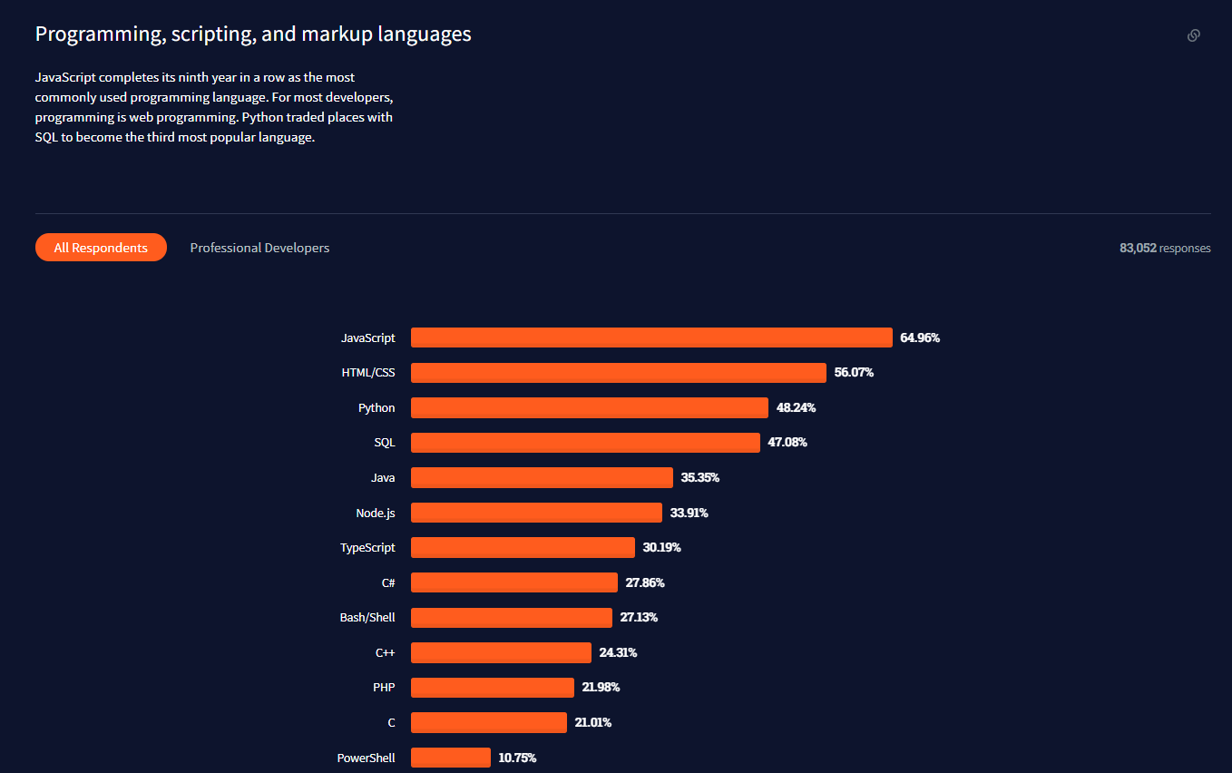

HTML
- https://en.wikipedia.org/wiki/HTML
  - HyperText Markup Language
  - “The standard markup language for documents designed to be displayed in a web browser.”

HTML5
- https://en.wikipedia.org/wiki/HTML5
  - “It is the fifth and last major HTML version that is a World Wide Web Consortium (W3C) recommendation.”
  - “It is maintained by the Web Hypertext Application Technology Working Group (WHATWG), a consortium of the major browser vendors (Apple, Google, Mozilla, and Microsoft).”
  - “It extends, improves, and rationalizes the markup available for documents and introduces markup and application programming interfaces (APIs) for complex web applications. For the same reasons, HTML5 is also a candidate for cross-platform mobile applications because it includes features designed with low-powered devices in mind.”
- For further study, visit https://www.w3schools.com/html/default.asp

CSS
- https://en.wikipedia.org/wiki/CSS
  - Cascading Style Sheets (CSS)
  - “A style sheet language used for describing the presentation of a document written in HTML
  - Separation of formatting and content
  - “The name cascading comes from the specified priority scheme to determine which style rule applies if more than one rule matches a particular element.”
- For further study, visit https://www.w3schools.com/css/default.asp

Section 1 - Preparing environment

- Use VS Code to open the folder you just created in HOS01A with name like IS312_module01_<yourName>.

- In VS Code open new terminal. Type the following command to create a directory called HOS01-html-css in the IS312_module01_<yourName>/ folder.

$ mkdir HOS01-html-css

Section 2 - Experiencing HTML

- Create a “public” directory under the “HOS01-html-css” directory and move to the directory.

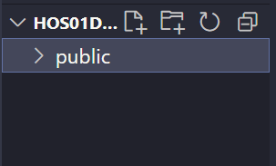
- Create an “index.html” file under the “public” directory.

- Type the following code in index.html you just created.

Please replace "HOS01D - HTML & CSS" in the 4th line of the screenshot with "HOS01 - HTML & CSS <yourName>" (<yourName> is your first name and last name).
Please keep this change in all subsequent steps.

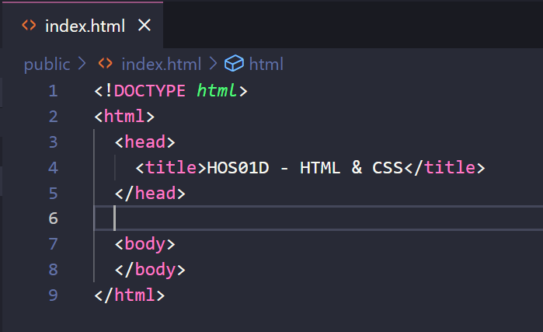

- By right-clicking the index.html file at the left Explorer panel in the vs code, select the “Reveal in File Explorer” item in the popup dropdown menu.

- Then, open the file in your web browser. Check the title of the web page.

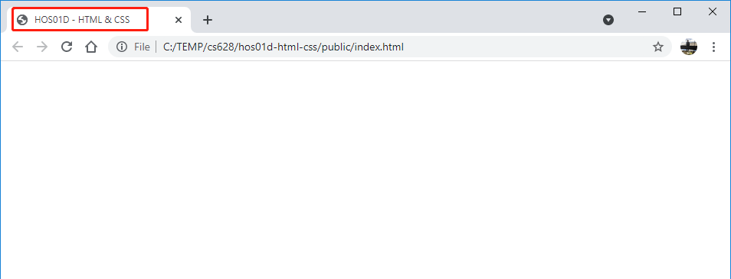

- Next, within the body, let’s create an <div> element that will eventually hold any React elements that we will create. This can be an empty <div>, but it needs an ID, say, contents, to identify it to get the element in JavaScript code.

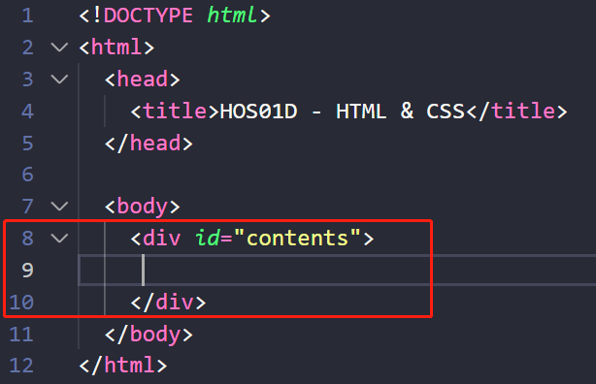

- Let’s create a very simple nested element — a <div> with a title attribute (just to show how attributes work) that contains a heading with the words “Hello HTML!”

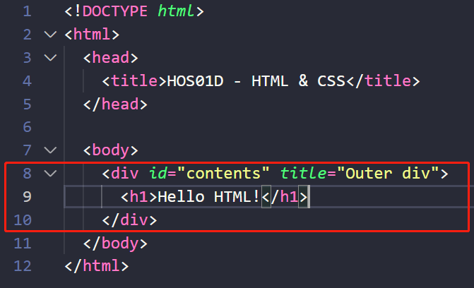

- By right clicking the file, select “Reveal in File Explorer” menu.

- Then, open the file in your web browser.
Check the title of the web page.
You should also be able to hover over the text or anywhere to its right side within the boundaries of the outer div, and you should be able to see the tooltip “Outer div” pop up.
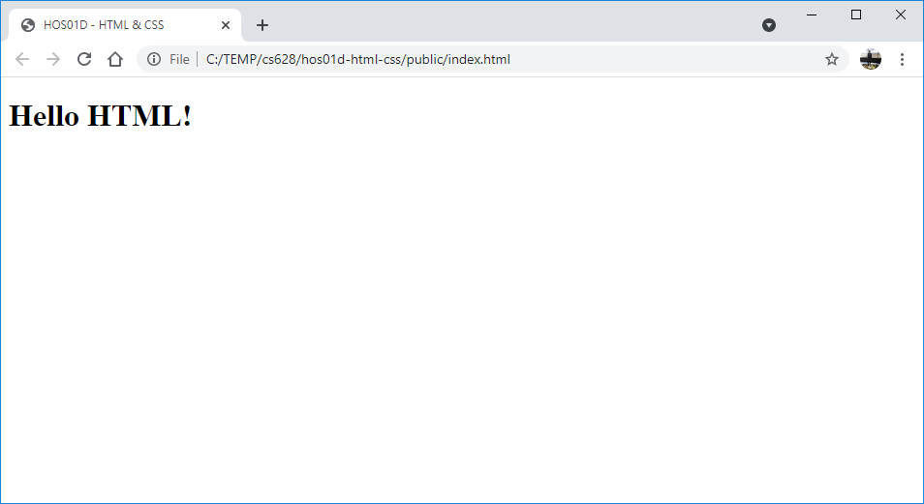

- By right-clicking in your web browser, select the “Inspect” menu.
Check each HTML tag in the “Elements” tab.

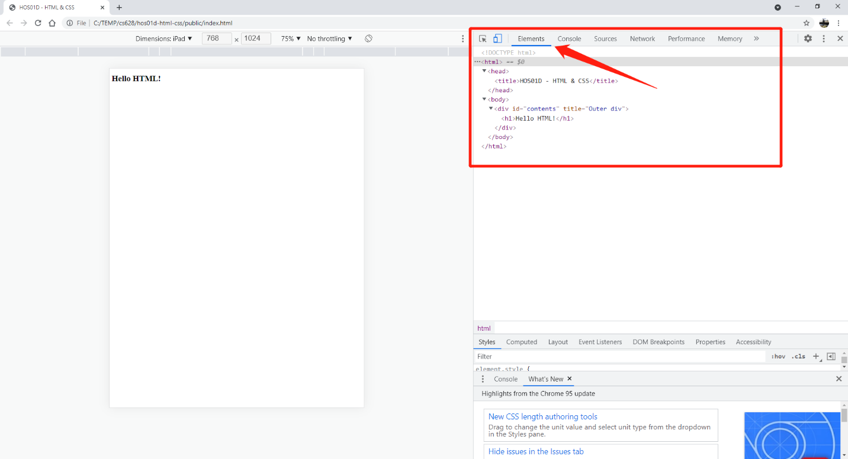

Section 3 - Experiencing CSS

- Defines metadata about an HTML document.
Specify the character encoding for the HTML document.

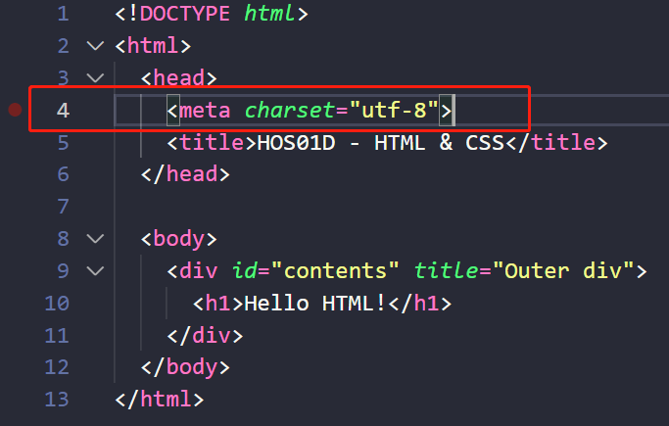

- Define the class in a <style> section within the <head> section.

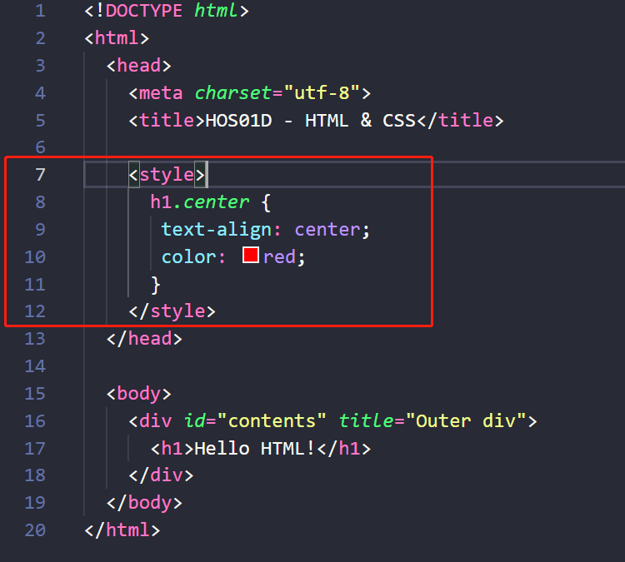

- Try to add a class to the <h1> element.

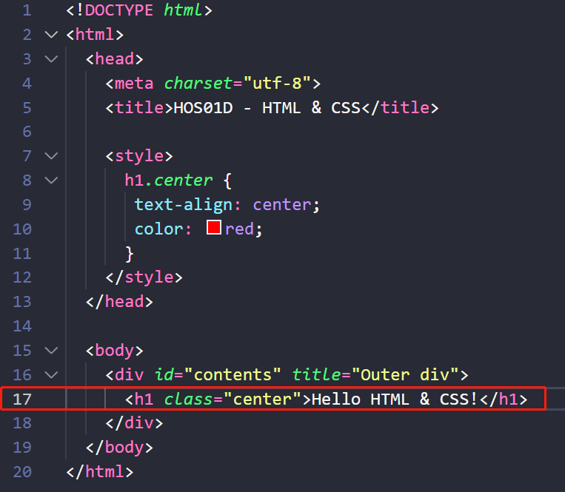

- By right clicking the file, select “Reveal in File Explorer” menu.

- Then, open the file in your browser.
Check the title of the web page.
You should also be able to hover over the text or anywhere to its right side within the boundaries of the outer div, and you should be able to see the tooltip “Outer div” pop up.

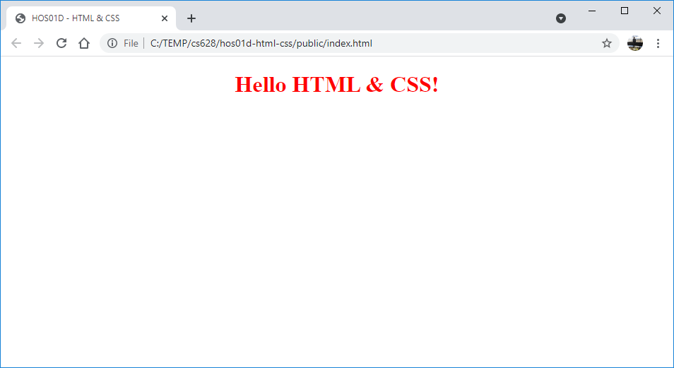

- By right-clicking in your web browser, select the “Inspect” menu.
Check each HTML tag in the “Elements” tab.

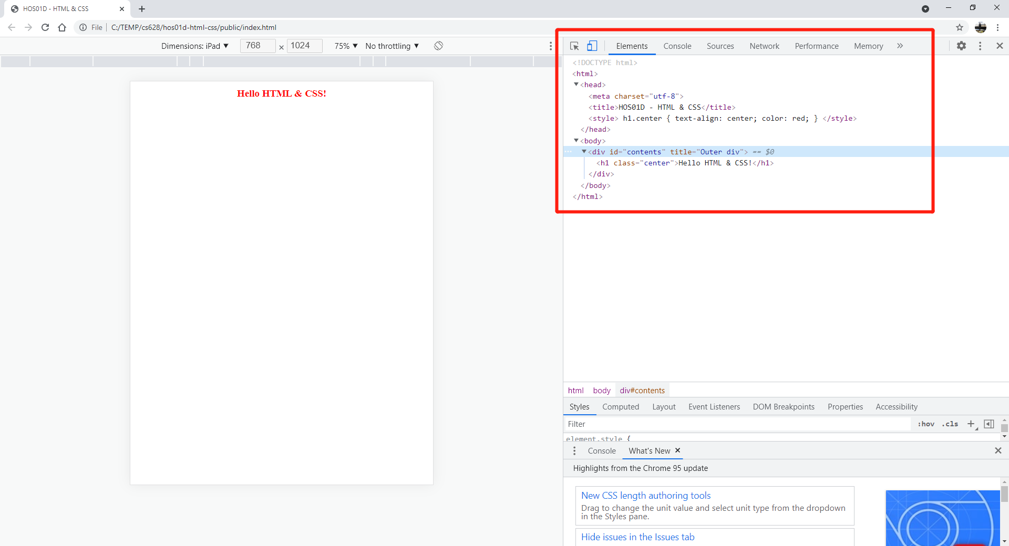

Upload the folder to the HOS01 GitHub repository.
git add .
git commit -m “HOS03 – your name”
git push

